Brad Hagemann, President

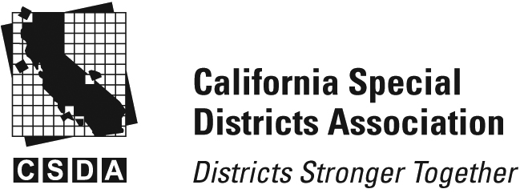

Scott Duffield, Vice-President

Kristen Gelos, Treasurer

Jana Etteddgue, Secretary

**San Luis Obispo County Chapter** Chapter

**CSDA – SLO County Chapter Meeting**

**Thursday, January 23, 2025**

**Café Roma**

**Deruta Banquet Room**

**Located at 1020 Railroad Ave, San Luis Obispo, CA 93405**

**Topic: Annual Meeting**

**Time: Doors open: 5:00pm**

**Cocktails: 5:00pm- 5:30pm**

**Dinner/Meeting: 5:30pm-6:30pm**

1. Welcome and Introductions by SLO CSDA Chapter President Brad Hagemann
2. Presentation by Matt Pontes, SLO County CAO
3. Update and Introduction from CSDA Coastal Network Public Affairs Field Coordinator, Richelle Noroyan
4. Update from Rob Fitzroy, LAFCO Update
5. Update from Peter Cron, IWMA Update
6. Chapter Business:

* Local SLO County CSDA Chapter Business/Update
  + SLO Chapter CSDA Board Election
    - Nominations will be taken from the floor for President, Vice President, Treasurer and Secretary- Each Director elected shall hold office for a term of one year or until a successor is elected.
  + Treasures Report

1. Adjournment