Brad Hagemann, President

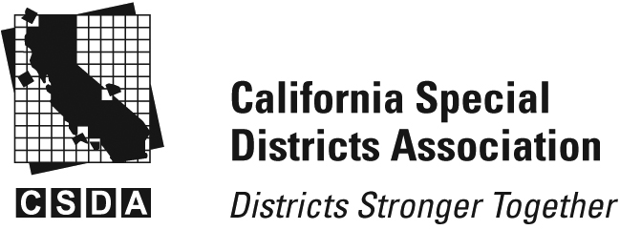

Scott Duffield, Vice-President

Kristen Gelos, Treasurer

Jana Etteddgue, Secretary

**San Luis Obispo County Chapter** Chapter

**CSDA – SLO County Chapter Meeting**

**Thursday, July 24, 2025**

**Cancellation notice**

**The regular meeting of July 24, 2025**

**has been cancelled.**